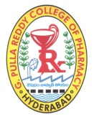
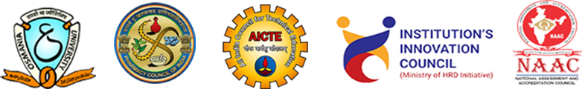

G. PULLA REDDY COLLEGE OF PHARMACY
Phone: 8297511177; Website: www.gprcp.ac.in; Email Id:gprcphyd@gmail.com
In collaboration with
CliMed RESEARCH SOLUTIONS, INDIA

DEPARTMENT OF PHARMACY PRACTICE
Organizing
THREE DAY NATIONAL LEVEL FACULTY DEVELOPMENT PROGRAMME (FDP) ON
EMERGING TRENDS IN CLINICAL RESEARCH AND HANDS ON TRAINING- 2023” 1st – 3rd March 2023
REGISTRATION FORM

Name | :
Education Qualification | :
Designation | :
Department | :
Experience (Yrs) | :
Area of Research | :
Name of the Institution | :
Address for the Correspondence | :
Mobile Number | :
Email Id | :

Date: Signature/Name
-------------------------------------------------------------------------------------------------------
- Kindly send the duly filled registration form by mail for confirmation of registration.
- Email Id: gprcp.pharmacypractice@gmail.com
- Pay the registration fee after confirmation of registration. (Rs.1200/-)
- Further information please contact: Prof.Dr. P.K.Lakshmi - 9000044452
- Ms.Sruthi Salla -8008379813

Last date of Registration : 23/2/2023

